Documentation for pointing website domains from different hosting
Referencing (ridimatuladhar.com.np (CPanel) and gr8nepal.com (Hostinger))
- The goal is to make ridimatuladhar.com.np load the website hosted on gr8nepal.com, while keeping all email services for ridimatuladhar.com.np intact.
- Website host: gr8nepal.com (Hostinger)
- Domain to point: ridimatuladhar.com.np (CPanel)
- Email: Host unchanged
Step 1: Update DNS Records (cPanel)
- Log in to the cPanel or DNS management for ridimatuladhar.com.np.
- Update the A record for the root domain (@) to point to the IP address of Hostinger server where gr8nepal.com is hosted.
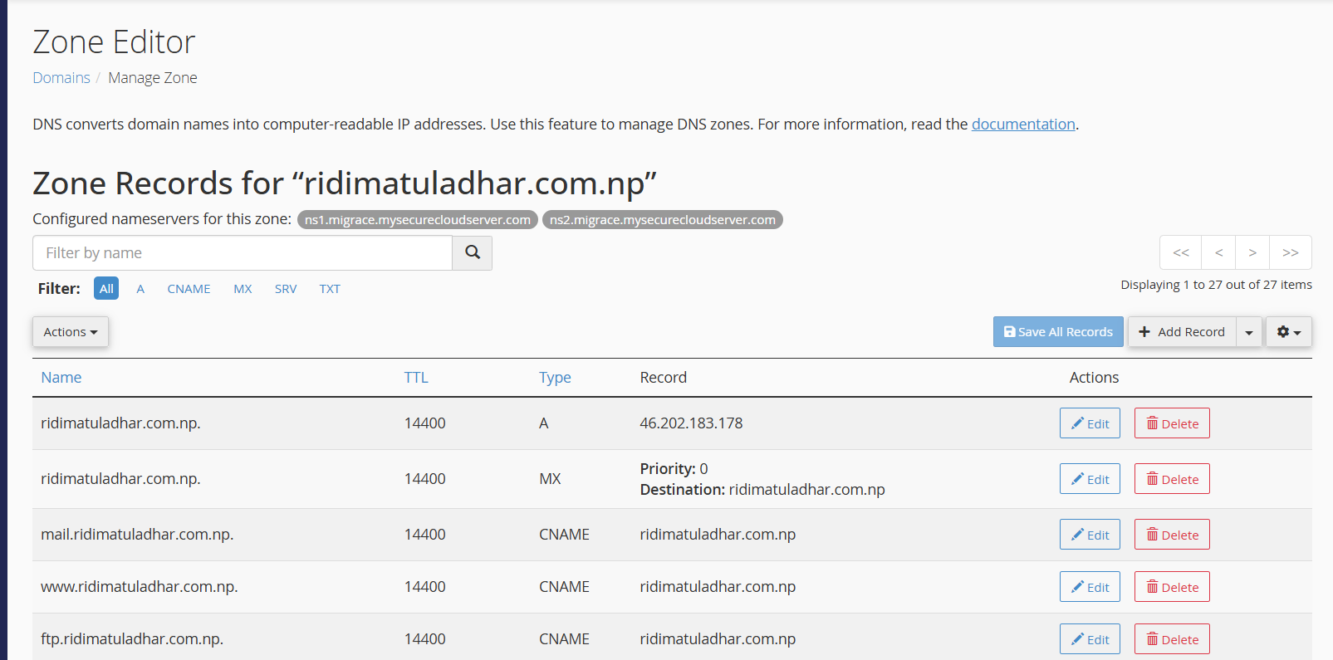
Change A record → Hostinger IP
- Do NOT change MX, SPF, DKIM, or any other email-related records. Emails will continue to work normally.

Step 2: Add ridimatuladhar.com.np as a Parked Domain on Hostinger
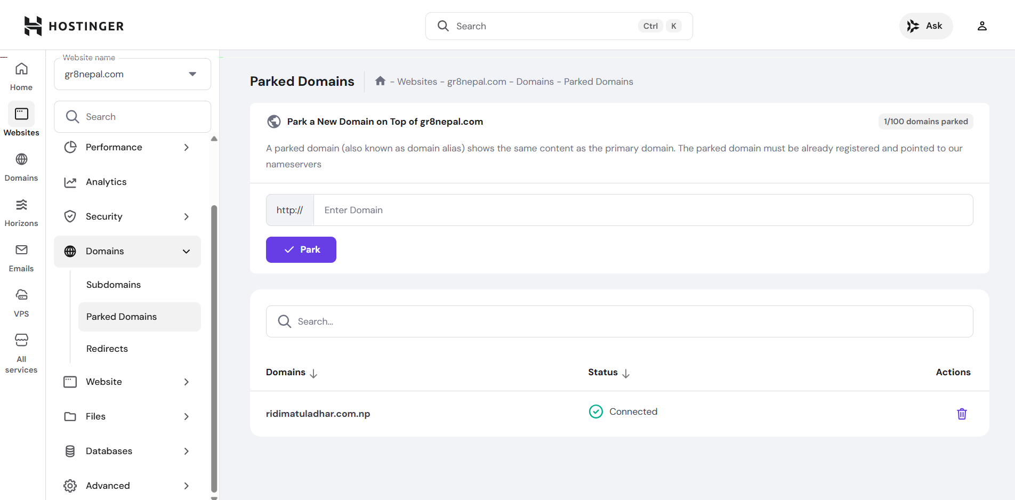
- Log in to Hostinger hPanel (for gr8nepal.com hosting).
- Go to Domains → Parked Domains / Domain Alias.
- Click Add New Parked Domain.
- Enter ridimatuladhar.com.np as the domain.
- Set the destination domain to gr8nepal.com.
- Click Add / Save.

